Badgers Homework - Term 1
Please choose 1 Maths and 1 Writing task each week. You need to complete 6 of each task over the term.
Maths
If I know 3 x 10 = 30, what else do I know? Write at least 20 calculations.  Explain how you know | Show your working:  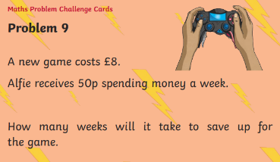 | If the answer to x is 12,  what could the value of the shapes be? Give all your answers.
Write the value of each underlined digit.  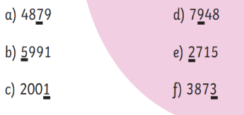 | 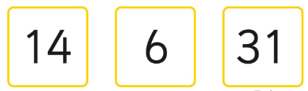  Which of these are the odd one out? Is there more than one answer? | Odd One Out:  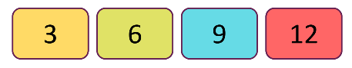  Can you find more than one odd one out?
Dora is thinking of a 6 digit number:  - It is an odd number  - The smallest digit has the greatest value.  - The largest digit has the smallest value.  - The first and last digit add up too 10.  - The first three digits also add up too 10.  - The last three digits add up too 20.  - The two middle digits are the same. | 2, 4, 5  Can you find 10 different answers?  You must use each number once in each calculation, but any operation and in any order.  eg, 2x4-5=3 | Complete the Multiplication wheels:
Writing
Each week, explain your reasons/opinions – in detail! You may want to start your explanations with the phrases below
If you could have a superpower, what would it be and why? | Would you like to climb a mountain? Why? | What if?  What if Dinosaurs were alive today? | Debate:  Books are better than Television.
Can you think of 3 materials that change state when they are heated? Can they change back again? | If the answer is ‘Time.’  Think of 10 possible questions. | Game:  Can you name all 11 parts of the body that have 3 letters? | Would you rather live on a mountain or in a town? Why?

