English – 08.09.2023

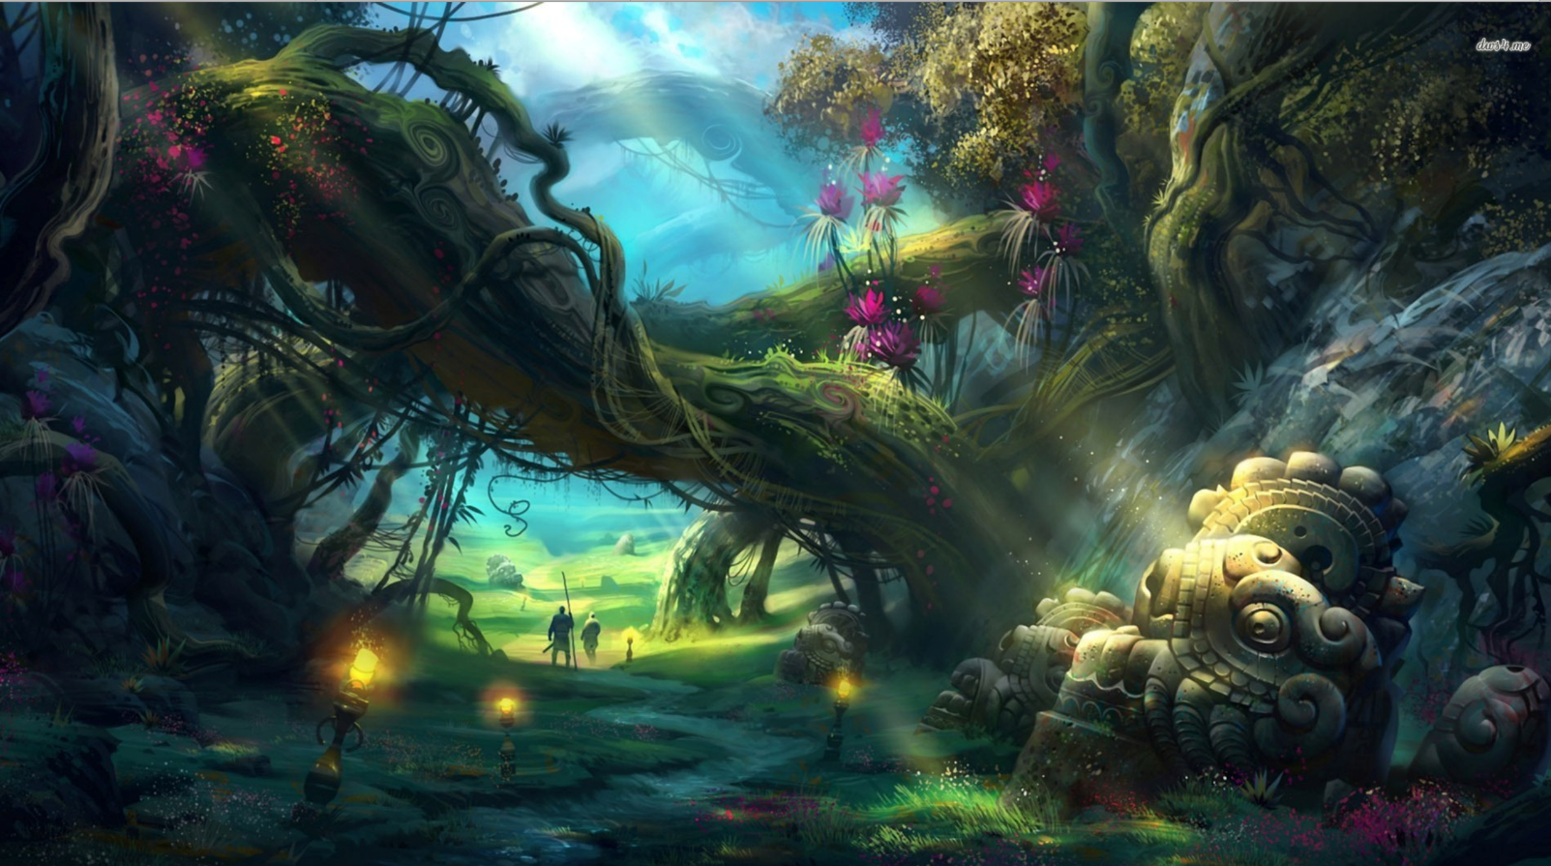
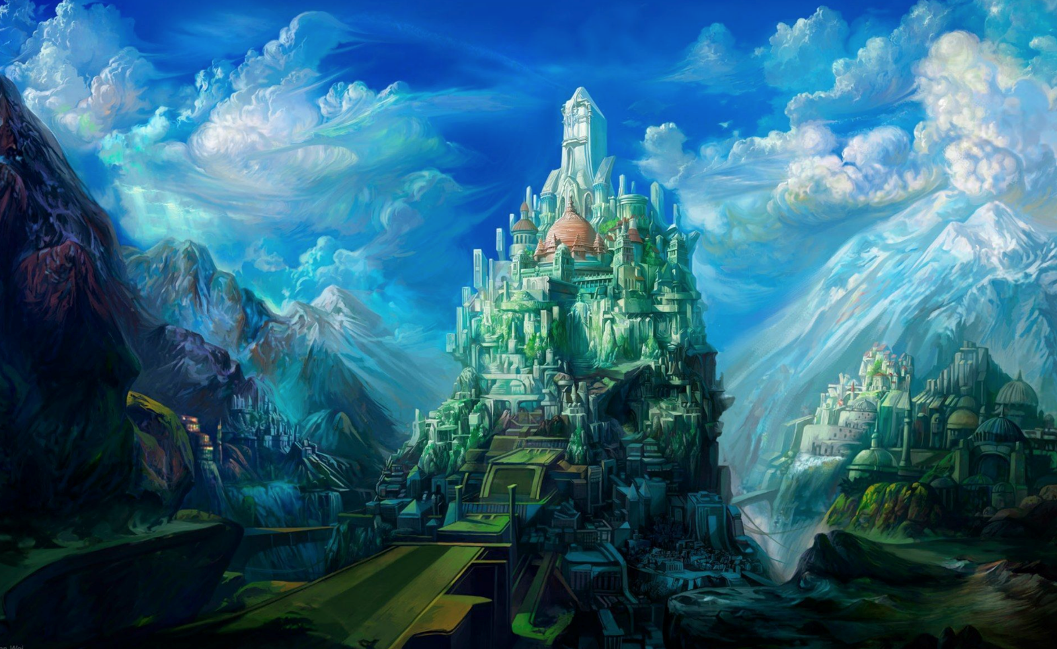
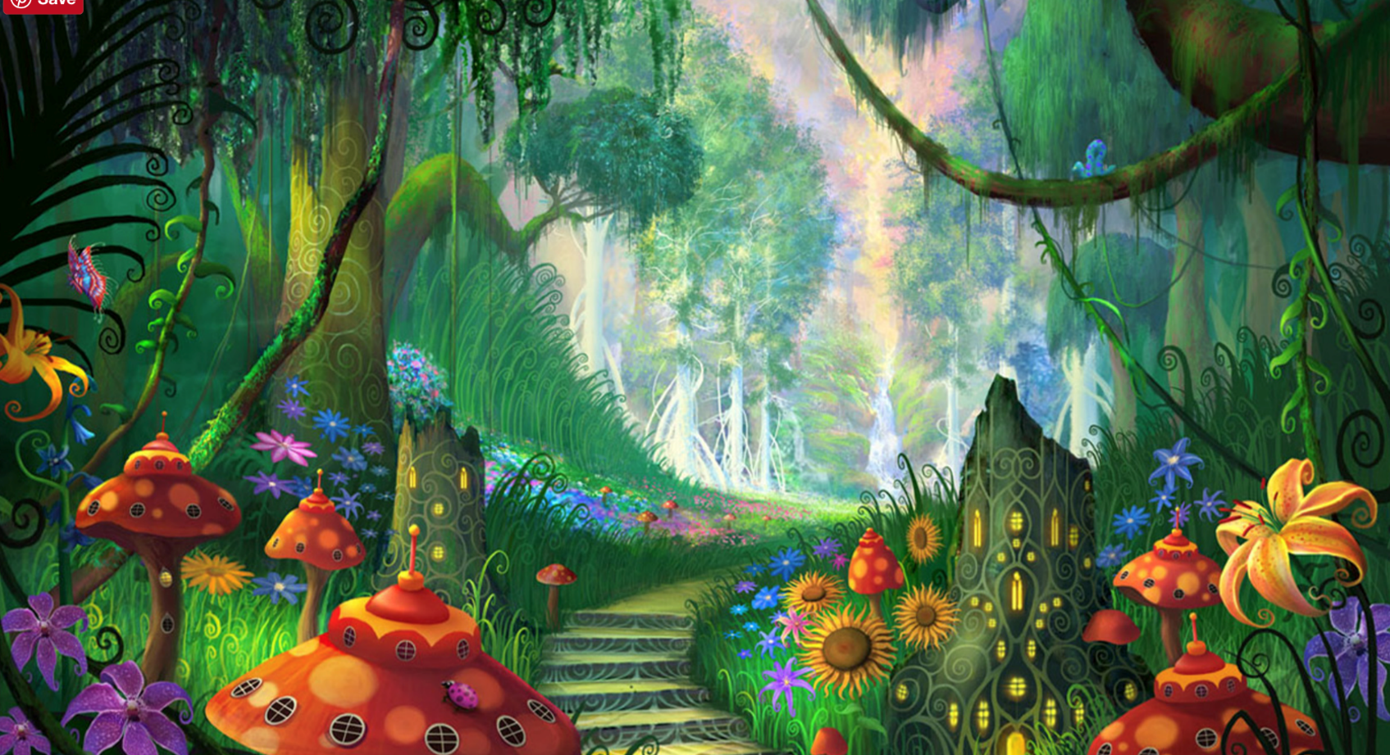
For this week’s homework, please choose one picture below and have a go at writing a paragraph describing the image you can see. Think about the different adjectives you can use and imagine that you are in the picture.

