Year 5 Maths – 08.09.2023
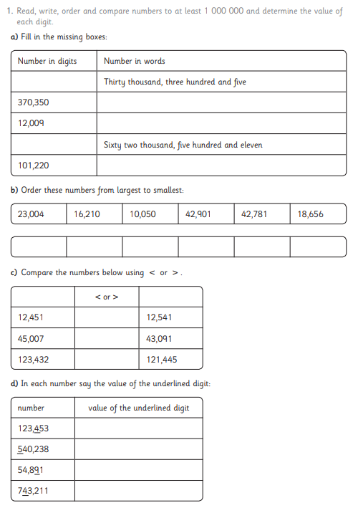
Please answer the questions in your books or onto the worksheet.

